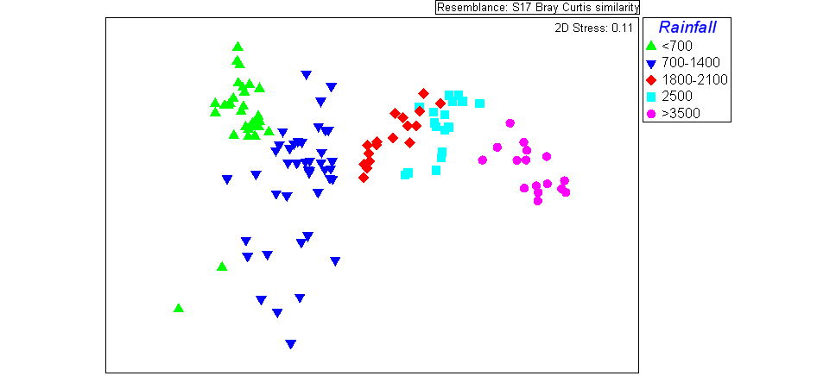

Figure X. Succession of soil microbial communities along the Kohala, HI precipitation gradient. Sites span 200-3500 mm annual rainfall on a 150,000 year-old lava flow. Community differences are shown by NMDS ordination of 16S rRNA gene iTag sequence data.



Figure X. Succession of soil microbial communities along the Kohala-Hawi precipitation gradient in Hawaii. Sites span 200-3500 mm annual rainfall on a ~150,000 year-old lava flow. Community differences are show by NMDS ordination of 16S rRNA gene iTag sequence data and compared to pedogenic thresholds and process domains defined by Vitousek and Chadwick (2013)